
Sulaimani Polytechnic University
Technical College of Informatics
Department of Information Technology
Automatic Schedule Generator
Prepared by: Peshawa Muhammed, Hiran Fahmi
Supervised by: M.Khalid
May 2021
Automatic Schedule Generator
Prepared by: Peshawa Muhammed , Hiran fahmy
Supervised by: M.Khalid
A Project submitted in partial fulfillment of the
requirements for the award of the Bachelor
Degree in Information Technology
Technical College of Informatics
Sulaimani Polytechnic University
May 2021

DECLARATION

Supervisor Declaration

“I hereby declare that I have read this project and in my
opinion this project is sufficient in terms of scope and quality for the
award of the bachelor degree in Information Technology”

Signature : .........................................................
Name of Supervisor: Khalid
Date : May 2021

Student Declaration

“I declare that this project entitled ‘Automatic Schedule Generator’ is the result of my own research except as cited in the references. The project has not been accepted for any degree and is not concurrently submitted in candidature of any other degree”

Signature : ………………………
Name of Student: Peshawa Muhammed, Hiran Fahmi
Date : May 2021

DEDICATION
We dedicate this project to any dormitory where they want manage movement of people there with an easiest way, and we dedicate to the department of Information Technology in college of informatics- SPU Our family, our friends, and our teachers.

ACKNOWLEDGMENT
First of all we will thank the GOD, and special thanks to our dear supervisor (Mr.Khalid) for giving us suitable way of writing the research and leaded us to make our project, thanks all persons and teachers who teach us even if it was a single letter , , thanks to our family , who encouraged us to do my best and never give up, finally , thanks to the Sulaimany polytechnics University, college of Informatics , Database department.

ABSTRACT
Timetable creation is a very arduous and time consuming task. To create timetable it takes lots of patience and man hours. Time table is created for various purposes like to organize lectures in school and colleges, to create timing charts for train and bus schedule and many more. To create timetable it requires lots of time and man power .In our paper we have tried to reduce these difficulties of generating timetable by Genetics Algorithm. By using Genetic algorithm we are able to reduce the time require to generate time table and generate a timetable which is more accurate, precise and free of human errors. The first phase contains all the common compulsory classes of the institute, which are scheduled by a central team. The second phase contains the individual departmental classes. Presently this timetable is prepared manually, by manipulating those of earlier years, with the only aim of producing a feasible timetable.

Table of Contents
DECLARATION iii
DEDICATION iv
ACKNOWLEDGMENT v
ABSTRACT vi
LIST OF FIGURES viii
LIST OF TABLES ix
CHAPTER ONE (INTRODUCTION) 1
1.1 Overview 1
1.2 Motivation 1
1.3 Problem Statement 1
1.5 Research Scope 2
1.6 Significant of Research 2
1.7 Organization 3
CHAPTER TWO (LITERATURE REVIEW) 4
2.1 Introduction 4
2.2 Framework 4
2.1 Automatic Timetable Generation using Genetic Algorithm 4
2.2 Timetable Generation System 5
2.3 Automatic Time Table Generator 5
2.4 Discussion and Conclusion 5
2.3 Summery 6
CHAPTER THREE (METHODOLOGY AND IMPLEMENTATION) 7
3.1 Introduction 7
3.2 Methodology 7
3.3 Research Methodology 7
3.3.1 Qualitative Research 8
3.3.2 Quantitative Methods 8
3.4 Extreme programming model 8
3.4.1 Research Process 9
3.5 Activity-Diagram 10
3.6 Use-case Diagram 11
3.7 ER-Diagram 11
3.8 Requirements 13
3.8.1 Visual Studio Microsoft Visual Studio 13
3.8.2 Database Management System 13
3.8.3 SQL Server 13
3.8.4 Programming Languages 14
3.9 Implementation 14
CHAPTER FOUR (CONCLUSION AND FUTURE WORK) 15
4.1 Conclusion 15
4.2 Future Work 15
REFERENCES 16

LIST OF FIGURES
Figure 1: Activity-Diagram 11
Figure 2: Use-case Diagram 12
Figure 3: ER Diagram 13

LIST OF TABLES

Table 1: Phases of project …………………………………………………………………. 17

CHAPTER ONE
- INTRODUCTION

1.1 Overview
The class timetabling problem is a typical scheduling problem that appears to be a tedious job in every academic institute once or twice a year. In earlier days, time table scheduling was done manually with a single person or some group involved in task of scheduling it manually, which takes a lot of effort and time. Planning timetables is one of the most complex and error-prone applications. Timetabling is the task of creating a timetable while satisfying some constraints. There are basically two types of constraints, soft constraints and hard constraints. Soft constraints are those if we violate them in scheduling, the output is still valid, but hard constraints are those which if we violate them; the timetable is no longer valid [1]. The search space of a timetabling problem is too vast, many solutions exist in the search space and few of them are not feasible. Feasible solutions here mean those which do not violate hard constraints and as well try to satisfy soft constraints. We need to choose the most appropriate one from feasible solutions. Most appropriate ones here mean those which do not violate soft constraints to a greater extent [1]. Using Genetics Algorithm, a number of trade-off solutions, in terms of multiple objectives of the problem, could be obtained very easily. Moreover, each of the obtained solutions has been found much better than a manually prepared solution which is in use.

1.2 Motivation
The current problems that we see daily in university time table need to solve with a system rather than hand and paper, because there are many problems in classes, teachers, lectures and students, that is why creating a system is the best way to solve these problems.

1.3 Problem Statement
The timetabling is a difficult problem, which is an element of the widen field of Scheduling. The scheduling problems belong to hard problems and are defined as an allocation problem of resources over time. The classes or lectures timetabling problem is usually solved by hand and taking several days or weeks of repair after feedback from staff and students in departments.
1.4 Research Objectives
The final system should able to generate time tables in completely automated way which will save a lot of time and effort of an institute administration. To make a timetable system generic so that I can work equally well for different School, Colleges and Universities. User defined constraints handling. Ease of use for user of system so that he/she can make automatic time table. Focus on optimization of resources i.e. teachers, labs and rooms etc. Provide a facility for everyone to view timetable.

1.5 Research Scope
Timetable Generation System generates timetable for each class and teacher, in keeping with the availability calendar of teachers, availability and capacity of physical resources (such as classrooms, laboratories and computer room) and rules applicable at different classes, semesters, teachers and subjects level. Best of all, this Timetable Generation System tremendously improves resource utilization and optimization.

1.6 Significant of Research
The proposed system is used to generate time table automatically. This ensures the following Features
• Easier slot assigning
• Less time consumption
• NO slot clashes
• Always considers the other department slots first
• Various possible slot combinations can be acquired
• User friendly

1.7 Organization
Chapter One: Project Structure
Chapter one provides a brief explanation of the project and how the product of the project works. Moreover, it can obtained information about what the project is doing, and for what purpose is used.
Chapter Two: Literature Review
In the second chapter the reader will be able to obtain the necessary information about most of the projects that done near our project. What’s more, it provides the type of researches method which has been applied to achieve the product of project.
Chapter Three: Methodology and Implementation
On the first hand, a variety of types of designs that were important to the development of the product have been discussed. It gives a screen design for the system pages of the product, and also in order to understand the project, it provides the rich picture. Furthermore, it presents different types of UML diagrams that were used by the product to analyze the problem. on the second hand, this chapter provides the reader with an overview of the implementation of the final product. Also in this chapter is going to provide the design and what does the system do and what our team achieved from the project or what the project is suited to the final product.
Chapter Four: Conclusion and Future Works
The last chapter is going to provide the summaries of the report and what our team achieved from the project or what the project is suited to the final product. What is more, it provides the information about our future works on the product to improve and maintain.

CHAPTER TWO
- LITERATURE REVIEW

2.1 Introduction
While we researched for this topic, we got information and help from some resource and researches that has been done before. And we are going to talk about them that what has been done and comparing them to know which one is better according to us.

2.2 Framework
Now we are going to talk about nearest researches near my research briefly which are these, (Automatic Timetable Generation using Genetic Algorithm), (Timetable Generation System), (Automatic Time Table Generator).

2.1 Automatic Timetable Generation using Genetic Algorithm
Timetable creation is a very arduous and time consuming task. To create timetable it takes lots of patience and man hours. Time table is created for various purposes like to organize lectures in school and colleges, to create timing charts for train and bus schedule and many more. To create timetable it requires lots of time and man power .In our paper we have tried to reduce these difficulties of generating timetable by Genetics Algorithm. By using Genetic algorithm we are able to reduce the time require to generate time table and generate a timetable which is more accurate, precise and free of human errors. The first phase contains all the common compulsory classes of the institute, which are scheduled by a central team. The second phase contains the individual departmental classes. Presently this timetable is prepared manually, by manipulating those of earlier years, with the only aim of producing a feasible timetable.

2.2 Timetable Generation System
This project introduces a practical timetabling algorithm capable of taking care of both strong and weak constraints effectively, used in an automated timetabling system. So that each teacher and student can view their timetable once they are finalized for a given semester but they can’t edit them. Timetable Generation System generates timetable for each class and teacher, in keeping with the availability calendar of teachers, availability and capacity of physical resources (such as classrooms, laboratories and computer room) and rules applicable at different classes, semesters, teachers and subjects level.

2.3 Automatic Time Table Generator
The manual system of preparing time table in colleges with large number of students is very time consuming and usually ends up with various classes clashing either at same room or with same teachers having more than one class at a time. to overcome all these problems , propose to make an automated system. The system will take various inputs like details of students, subjects and class rooms and teachers available, depending upon these inputs it will generate a possible time table, making optimal utilization of all resources in a way that will best suit any of constraints or college rules. List of subjects may include electives as well as core subjects.

2.4 Discussion and Conclusion
Genetic algorithms are general search and optimization algorithms inspired by processes and normally associated with natural world. Genetic algorithm mimics the process of natural selection and can be used as a technique for solving complex optimization problems which have large spaces. They can be used as techniques for solving complex problems and for searching of large problem spaces. Unlike many heuristic schemes, which have only one optimal solution at any time, Genetic algorithms maintain many individual solutions in the form of population. Individuals (parents) are chosen from the population and are then mated to form a new individual (child). The child is further mutated to introduce diversity into the population [10].Rather than starting from a single point within the search space, GA is initialized to the population of guesses. These are usually random and will bespread throughout the search space. A typical algorithm then uses three operators, selection, crossover and mutation, to direct the population toward convergence at global optimum. A GA, as shown in figure 1 requires a process of initializing, breeding, mutating, choosing and killing. It can be said that most methods called GAs have at least the following elements in common: Population of chromosomes, Selection according to fitness, Crossover to produce new offspring, and random mutation of new offspring.

2.3 Summery
These researches are the nearer researches near to our research that helped us and we talked about each of them shortly and we discussed them and compared them according their properties. In next chapter we will talk about the methodology, steps and plans of project and talk about them.

CHAPTER THREE
- RESEARCH METHODOLOGY

3.1 Introduction
Each project and research has its own plan to do, and our project also has some steps and plans that we will talk about in this chapter also we are going to talk about the implementation of the system briefly because if project doesn’t have plan to do, then that project will get fail, that is why we created this project after analyzing fully.

3.2 Methodology
Methodology implies more than simply the methods you intend to use to collect data. it is often necessary to include a consideration of the concepts and theories which underlie the methods. for instance, if you intend to highlight a specific feature of a sociological theory or test an algorithm for some aspect of information retrieval, or test the validity of a particular system, you have to show that you understand the underlying concepts of the methodology. when you describe your methods it is necessary to state how you have addressed the research questions and/or hypotheses. the methods should be described in enough detail for the study to be replicated, or at least repeated in a similar way in another situation. every stage should be explained and justified with clear reasons for the choice of your particular methods and materials.

3.3 Research Methodology
Research methodology. The process used to collect information and data for the purpose of making business decisions. The methodology may include publication research, interviews, surveys and other research techniques, and could include both present and historical information. We have a 2 type of methodology which are these:

3.3.1 Qualitative Research
Qualitative research seeks to explore specific phenomena, not prove a prediction, according to qualitative research methods: a data collector's field guide, published by family health international. Often used in the social sciences and education, qualitative methodologies use interviews, focus groups and observations to collect data. Qualitative methods provide rich, contextual explorations of the topic that are often personally or culturally meaningful.

3.3.2 Quantitative Methods
Quantitative research is more objective than qualitative methods. in this type of methodology, the researcher crafts a hypothesis and then tests it through structured means. Instead of exploring or describing phenomena, quantitative methods deal with facts and statistics. This type of research is often used in science or medicine.

3.4 Extreme programming model
Extreme Programming is a software development methodology designed to improve the quality of software and its ability to properly adapt to the changing needs of the customer or client. During the mid and late nineties, while working on the Chrysler Comprehensive Compensation System (C3) to help manage the company’s payroll, software engineer Ken Beck first developed the Extreme Programming methodology. detailing the entire method for others, and shortly thereafter the official website was launched as well. Similar to other Agile Methods of development, Extreme Programming aims to provide iterative and frequent small releases throughout the project, allowing both team members and customers to examine and review the project’s progress throughout the entire SDLC. Software development based on values of simplicity, communication and feedback. It works by bringing the whole team together in the presence of simple practices, with enough feedback to enable the team to check where they are, and to tune the practices to their unique situation.
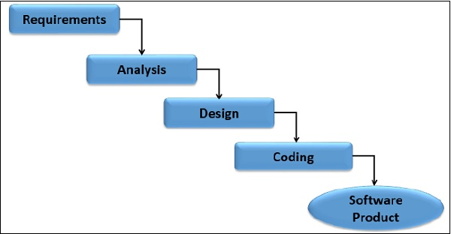

3.4.1 Research Process

Table 1: Phases of Project
Phases | Works | Description
1 | Requirement | First of all, we chose a project to solve our problem that we have with an easy way. Checked that, can we get those equipment or not.
2 | Analysis | Asking users that work in that place and reading about the researches that has done before about this system.
3 | Design | Designed User Interface with a new design and easy to learn with fully property. Designed the system and the database.
4 | Codding | Then connecting system with a software that designed to show times, Write all program codes that do the jobs.
5 | Testing | Test project to find any error or something else from program.
6 | Software Product | Working the system properly on the place.

3.5 Activity-Diagram
Activity diagram is another important behavioral diagram in UML diagram to describe dynamic aspects of the system. Activity diagram is essentially an advanced version of flow chart that modeling the flow from one activity to another activity.
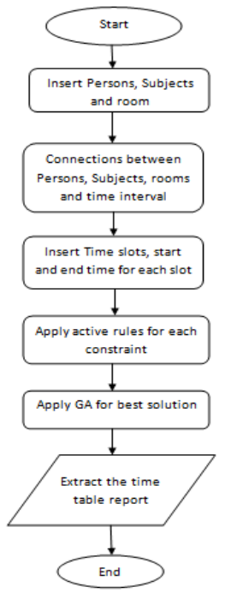
Figure 1 Activity-Diagram

3.6 Use-case Diagram

A use case diagram at its simplest is a representation of a user's interaction with the system that shows the relationship between the user and the different use cases in which the user is involved. A use case diagram can identify the different types of users of a system and the different use cases and will often be accompanied by other types of diagrams as well. The use cases are represented by either circles or ellipses.

Figure 2: Use-case Diagram

3.7 ER-Diagram

The ER or (Entity Relational Model) is a high-level conceptual data model diagram. Entity-Relation model is based on the notion of real-world entities and the relationship between them.
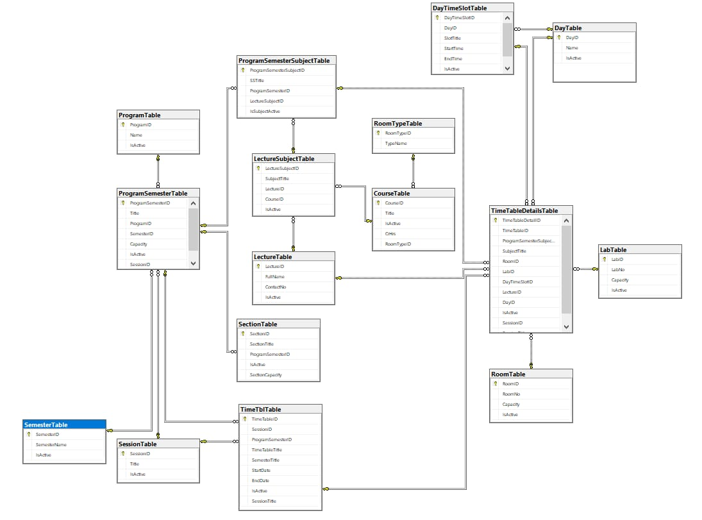
Figure 3: ER Diagram

3.8 Requirements

System requirements are the configuration that a system must have in order for a hardware or software application to run smoothly and efficiently. Failure to meet these requirements can result in installation problems or performance problems. The former may prevent a device or application from getting installed, whereas the latter may cause a product to malfunction or perform below expectation or even to hang or crash.

3.8.1 Visual Studio Microsoft Visual Studio
Is an integrated development environment (IDE) from Microsoft. It is used to develop computer programs, as well as websites, web apps, web services and mobile apps [6]. Visual Studio uses Microsoft software development platforms such as Windows API, Windows Forms, Windows Presentation Foundation, Windows Store and Microsoft Silverlight. It can produce both native code and managed code. Visual Studio includes a code editor supporting IntelliSense (the code completion component) as well as code refactoring. The integrated debugger works both as a source-level debugger and a machine-level debugger. Other built-in tools include a code profiler, designer for building GUI applications, web designer, class designer, and database schema designer. It accepts plug-ins that enhance the functionality at almost every level—including adding support for source control systems (like Subversion and Git) and adding new toolsets like editors and visual designers for domain-specific languages or toolsets for other aspects of the software development lifecycle (like the Azure DevOps client: Team Explorer).Visual Studio supports 36 different programming languages and allows the code editor and debugger to support (to varying degrees) nearly any programming language, provided a language-specific service exists.

3.8.2 Database Management System
A database management system (DBMS) is a software package designed to define, manipulate, retrieve and manage data in a database. A DBMS generally manipulates the data itself, the data format, field names, record structure and file structure. It also defines rules to validate and manipulate this data. A DBMS relieves users of framing programs for data maintenance. Fourth-generation query languages, such as SQL, are used along with the DBMS package to interact with a database.

3.8.3 SQL Server
SQL Server is a relational database management system (RDBMS) developed by Microsoft. This product is built for the basic function of storing retrieving data as required by other applications. It can be run either on the same computer or on another across a network. This tutorial explains some basic and advanced concepts of SQL Server such as how to create and restore data, create login and backup, assign permissions, etc. Each topic is explained using examples for easy understanding.

3.8.4 Programming Languages
A programming language is a formal language, which comprises a set of instructions that produce various kinds of output. Programming languages are used in computer programming to implement algorithms. Most programming languages consist of instructions for computers. There are programmable machines that use a set of specific instructions, rather than general programming languages.

3.9 Implementation

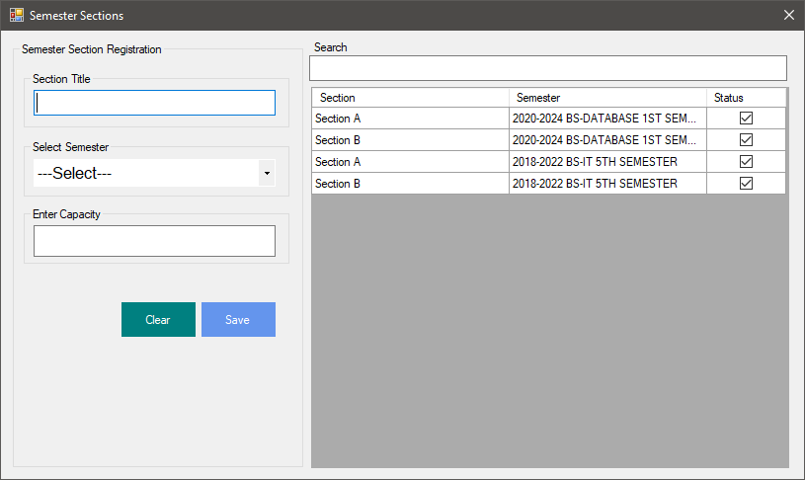
Figure 4: Semester Form
This form Use for add group for Semester for example add tow group for IT semester 2
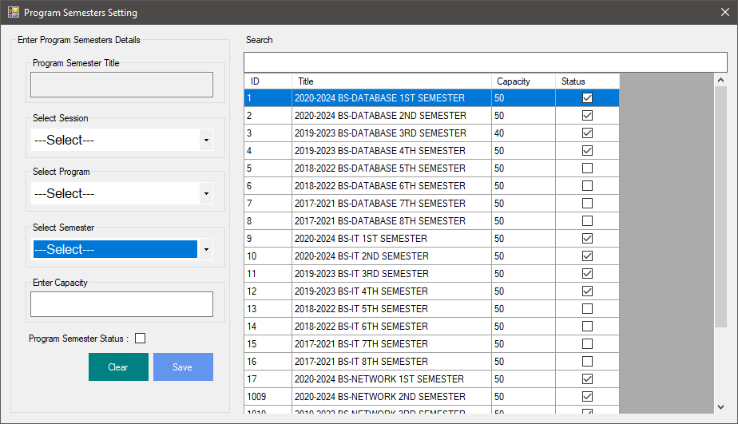
Figure 5: Program Form
This form for assign semester to program for example IT have for semester(stage)
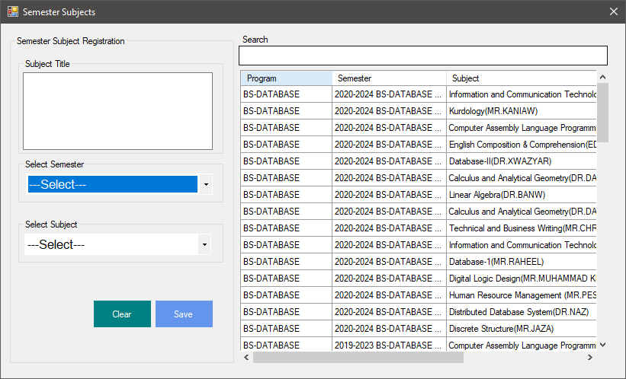
Figure 6: Semester Form
This form use for assign subject to all semester for example in semester 1 IT program (kurdology,IT fundamental ,..)
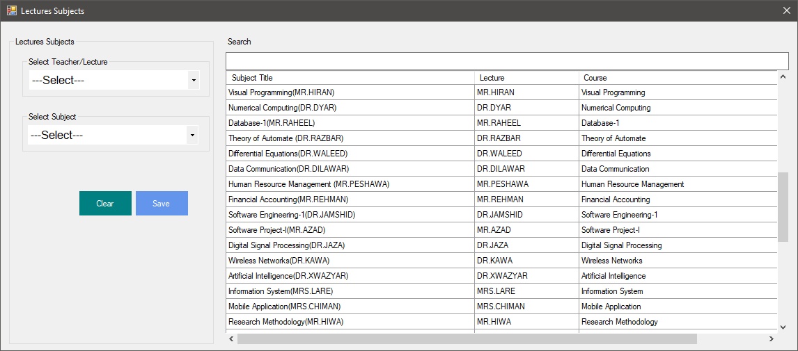
Figure 7: Assign Subject To Lecturer Form
This form use for assign subject for all teacher for example MR.Peshawa teacher OOP
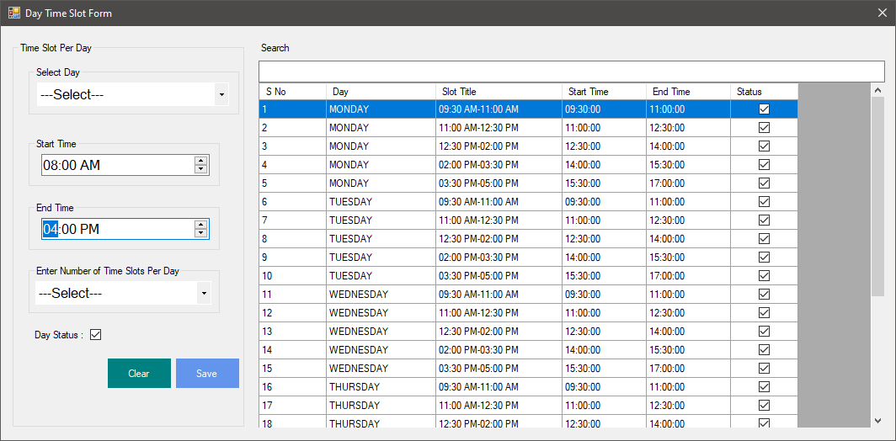
Figure 8: Day Time Slot Form
This form use for add number of time slot per day for example in Monday we have four lecture all lecture have 2 hours
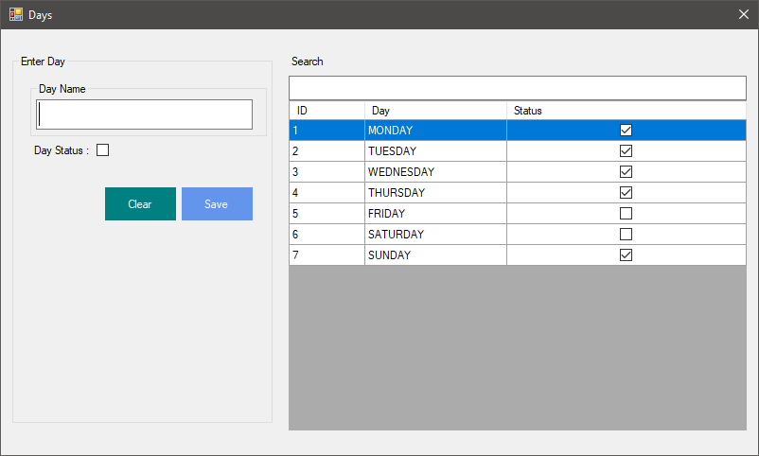
Figure 9: Days Form
In this form add all days for example in some university we have lecture for three days
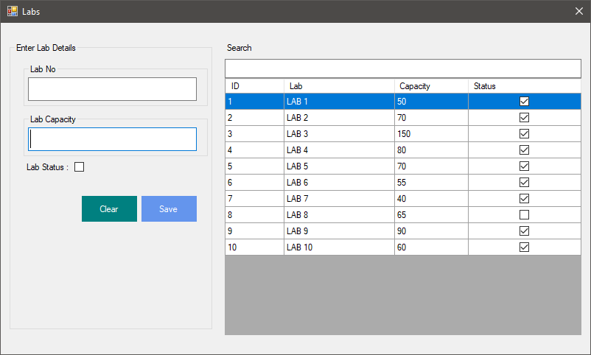
Figure 10: Labs Form
This form for add labs and student capacity
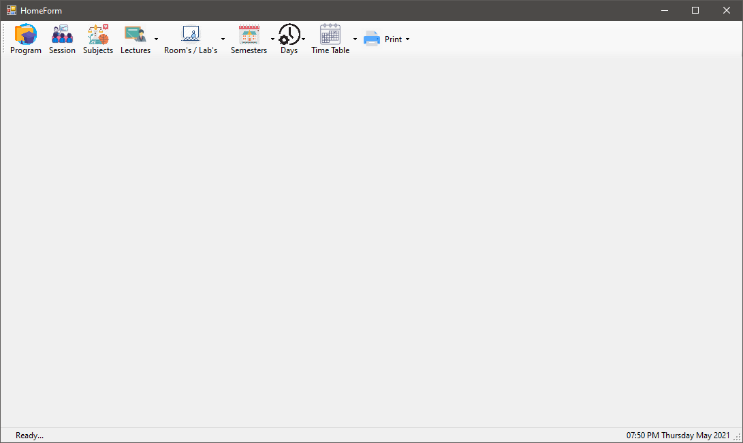
Figure 11: Home Page
This is the main form for access all other form
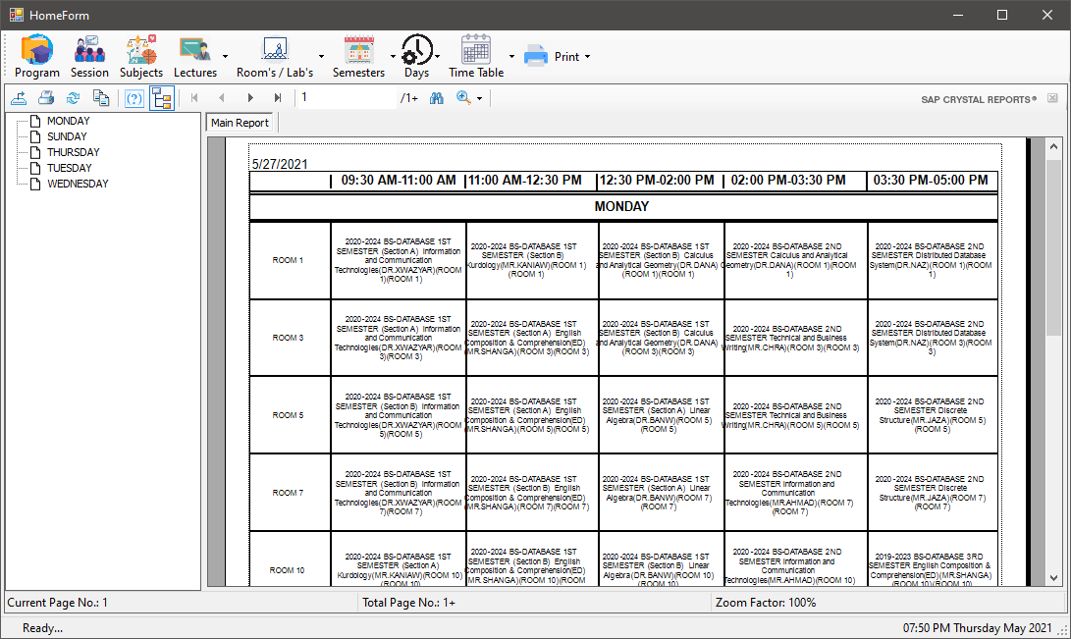
Figure 12:Print All Day Wise TimeTable
After add all data then generate timetable and print all timetable
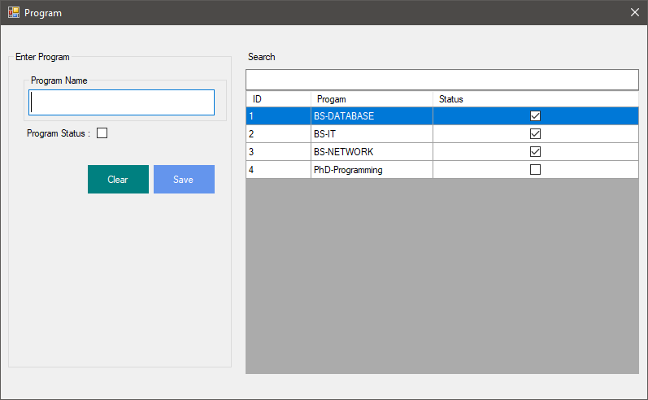
Figure 13: Program Form
This form for add program study for example in informatic we have three department like IT,Database,Network then onther university have PhD program we can add all program
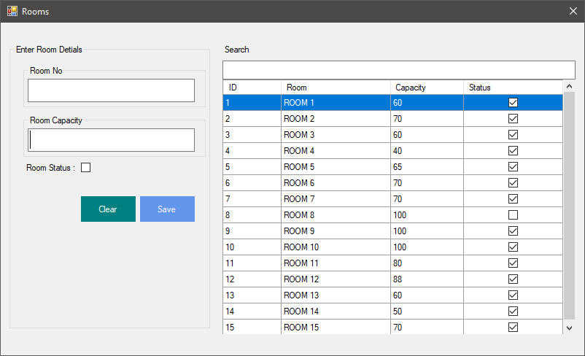
Figure 14: Rooms
This form use for add room(hall) and student capacity
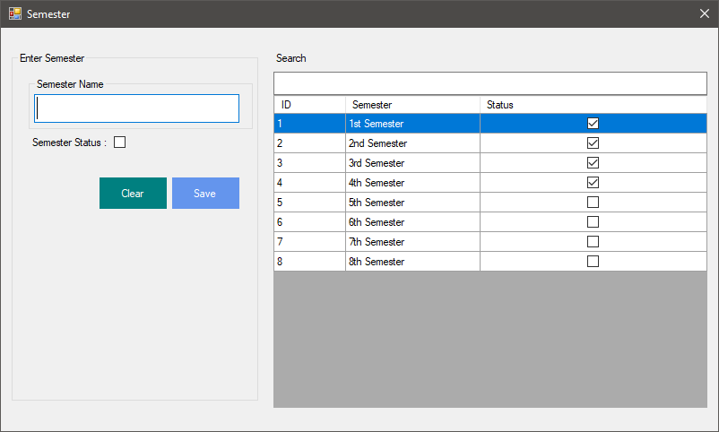
Figure 15: Semester Form
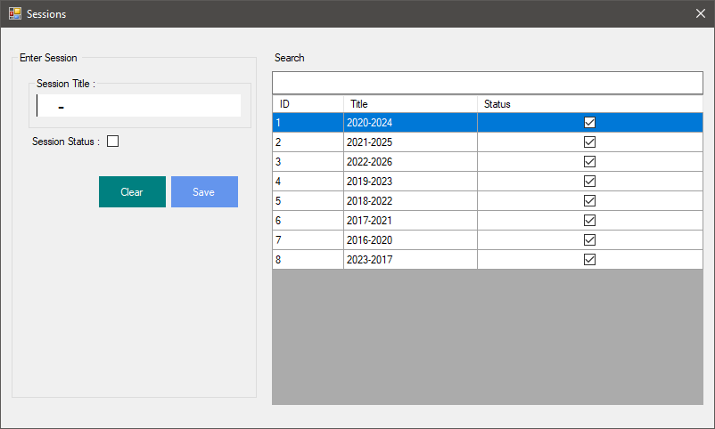
Figure 16: Session Form
This form use for add session
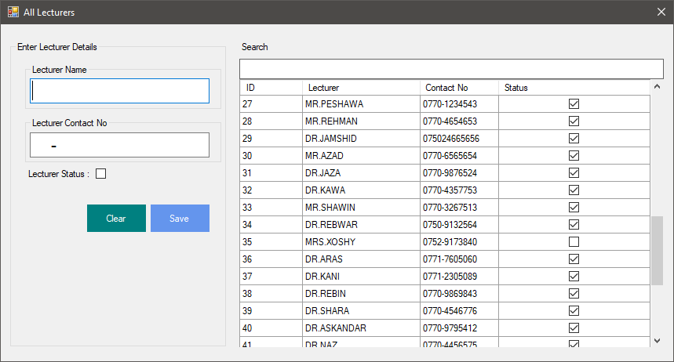
Figure 17: All Lectures Page
This form use for add Teacher

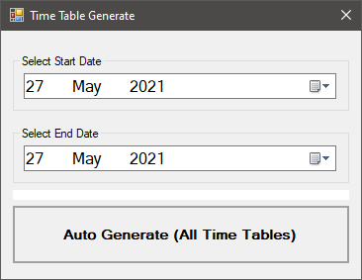
Figure 18: Time Table Generate Form

After insert all data then select start date and end date timetable after that need generate timetable this form use for create time table by using genetic algorithm

CHAPTER FOUR
- CONCLUSION AND FUTUREWORK

4.1 Conclusion
Even though most college administrative work has been computerized, the lecture timetable scheduling is still mostly done manually due to its inherent difficulties. The manual lecture timetable scheduling demands considerable time and efforts. The lecture-timetable scheduling is a Constraint satisfaction problem in which we find a solution that satisfies the given set of constraints. A college timetable is a temporal arrangement of a set of lectures and classrooms in which all given constraints are satisfied. Creating such timetables manually is complex and time consuming process. By automating this process with computer assisted timetable generator can save a lot of precious time of administrators who are involved in creating and managing course timetables. Since every college has its own timetabling problem, the commercially available software packages may not suit the need of every college. Hence we have developed practical approach for building lecture course timetabling system, which can be customized to fit to any colleges timetabling problem. The college lecture-timetabling problem asks us to find some time slots and classrooms which satisfy the constraints imposed on offered.

4.2 Future Work
In the future we want to make the system better through adding more feature like adding the days that teachers cannot come to their lectures to be organized by system and do not put any lecture on those days, and adding priority to the class which should be reserve by one department.

REFERENCES

M. Doulaty, M. R. FeiziDerakhshi, and M. Abdi, “Timetabling: A State-of-the-Art Evolutionary Approach”, International Journal of Machine Learning and Computing,Vol. 3, No. 3, June 2013. (Online Restaurant Management System) published Date: 2017-05, publisher Imtiaz Ahmed and Shahrear Kabir.

(Automatic Timetable Generation using Genetic Algorithm) Inventor : Dipesh Mittal, Hiral Doshi,Mohammed Sunasra, Vol. 4, Issue 2, Published: February 2015.

(Timetable Generation System) Inventor: Anuja Chowdhary, Priyanka Kakde, Shruti Dhoke, Vol. 3, Issue. 2, Published: February 2014.

(Automatic Time Table Generator) author: Saritha M, Pranav Kiran Vaze, Pradeep, Mahesh N R, Volume 7, Issue 5, Published: May 2017.

(Reading SQL Server Data) Author: Ryan Wade, published 13 October 2020.

(C# Programming Language) Addison-Wesley Professional Authors: Anders Hejlsberg Mads Torgersen, Published 2016.

